**Rohith Ramesh**

**1001518031**

**Buffer Overflow Vulnerability Lab**

In order to execute the lab tasks, we perform the following activities as a prerequisite

* We disable address space layout randomization
* Change the default shell from dash to zsh in order to avoid the countermeasures Implemented in bash
* Providing the -z execstack makes the stack executable
* -fno-stack-protector turns off the stack guard protection scheme

**Task-1**: **Running The Shell Code**

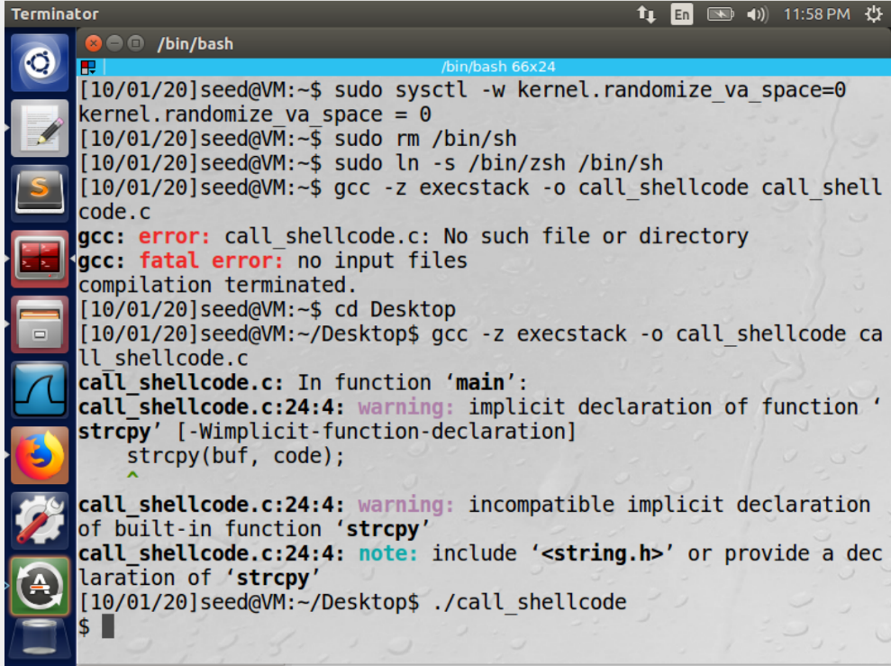

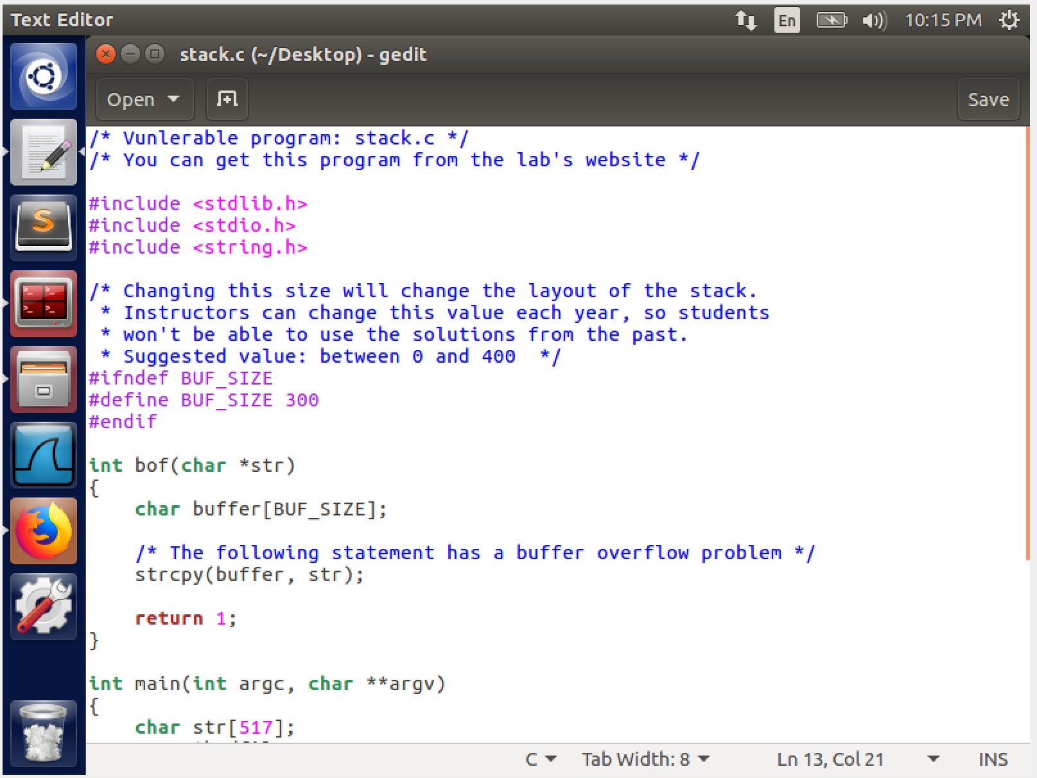

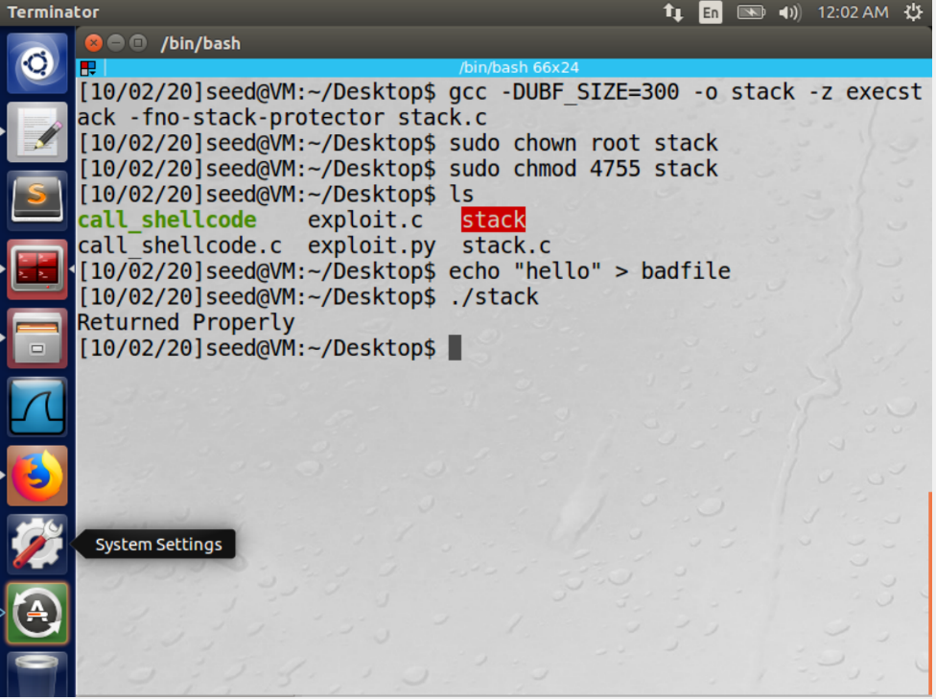

We compile call_shellcode.c by passing “-z execstack” as a parameter which makes the stack executable. On executing the program, we have access to the shell of our account which is indicated by the “$” symbol, thus giving access to ‘/bin/sh’.

Since the program was not a SET-UID program and not being in the root account, the shell terminal obtained as a result is that of our account and not the root account.

we compile and execute the given vulnerable program stack.c . we also, we disable the StackGuard Protection mechanism and make it into a SET-UID program.

**Task 2: Exploiting the Vulnerability**

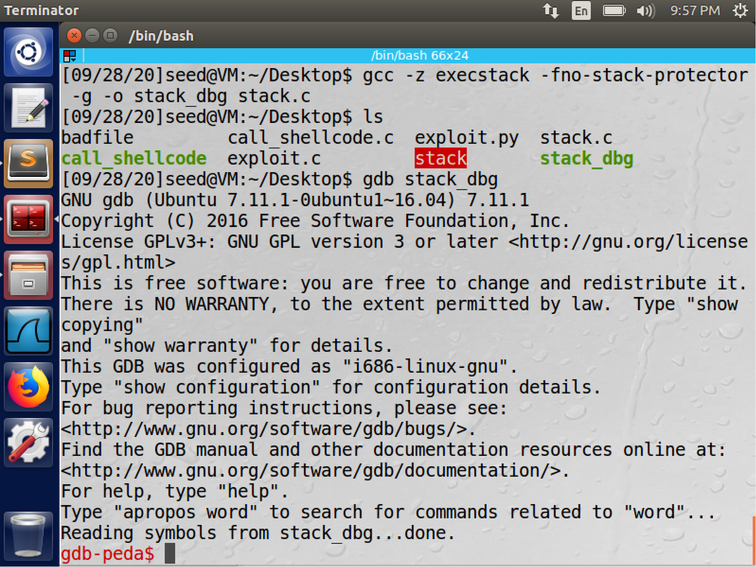

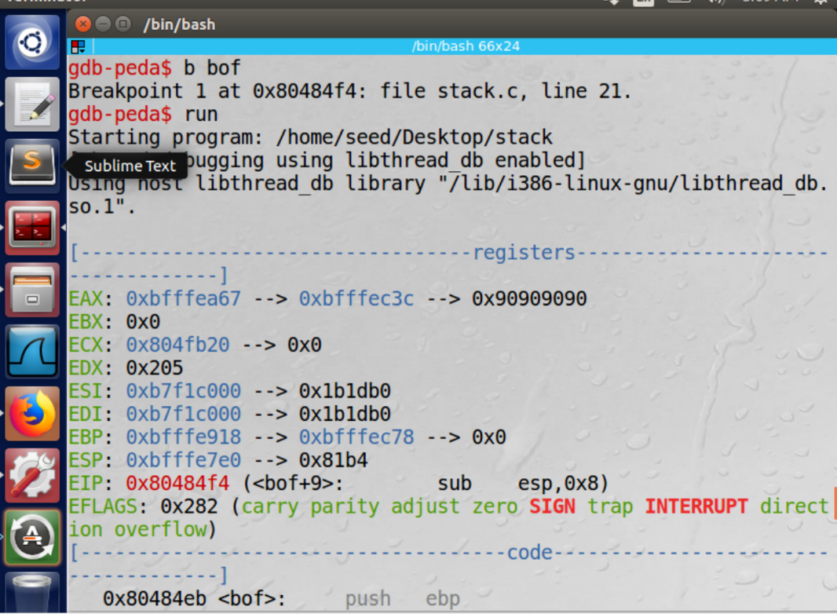

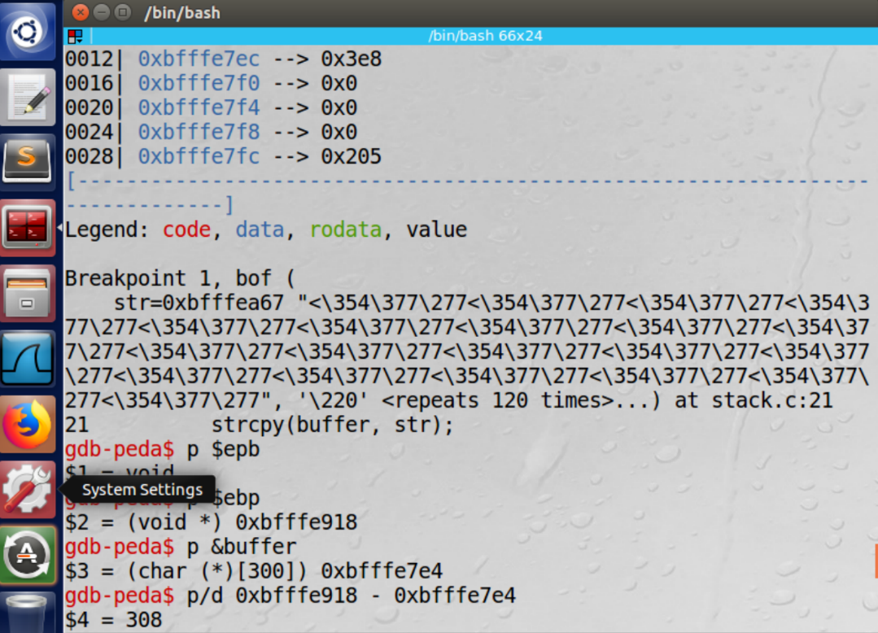

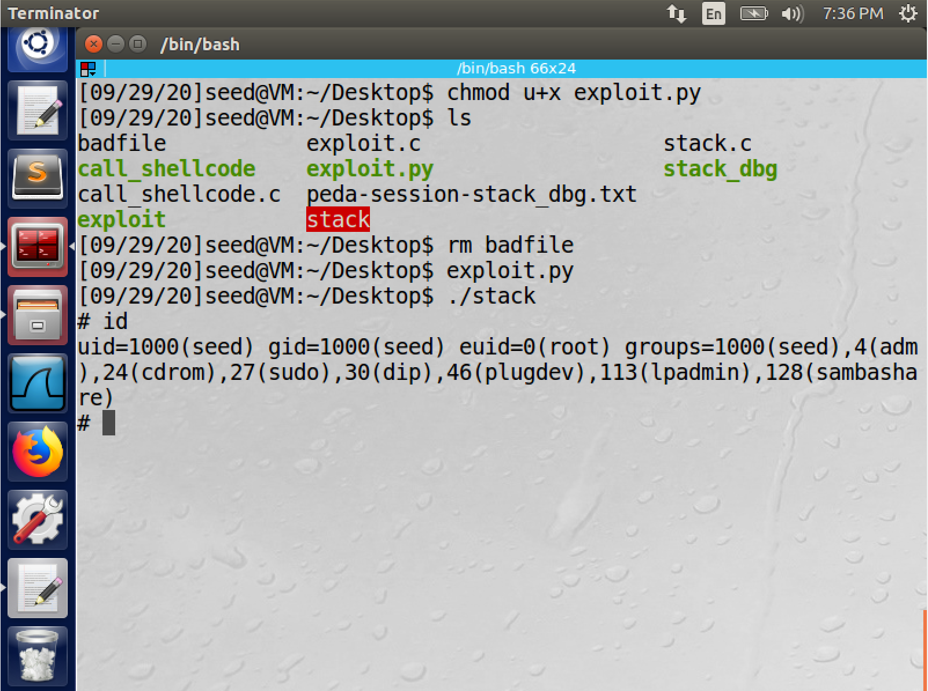

The program is compiled and run in debug mode so that we can find the addresses in the memory, which will help us find the ebp and the offset value using which we can construct the buffer load to overload the buffer . In gdb, we set a breakpoint on the bof function using b bof, and then begin running the program. The program breaks execution inside the bof function because of the breakpoint we had created.

we find the difference between the ebp and start of the buffer in order to find the value of the return address. Here, we see that the ebp is 0xbfffeb918 and hence the return address should be placed in 0xbfffeb198 + 4.

The difference between the return address and buffer start address, Gives us the location to store the return address. The return address will be 4 places above the ebp. Hence, the distance between the return address and the start of the buffer is 308, therefore the return address should be stored with an offset of 312.

We edit the given python code and run the executable stack and python programs. The # sign indicates that we have gained root priviliges.

But the user id (uid) and the effective user id (euid) are not equal. Therefore, we compile the given program and name it makeitroot.Having secured root privileges we execute this program in the root terminal to set the uid to 0.

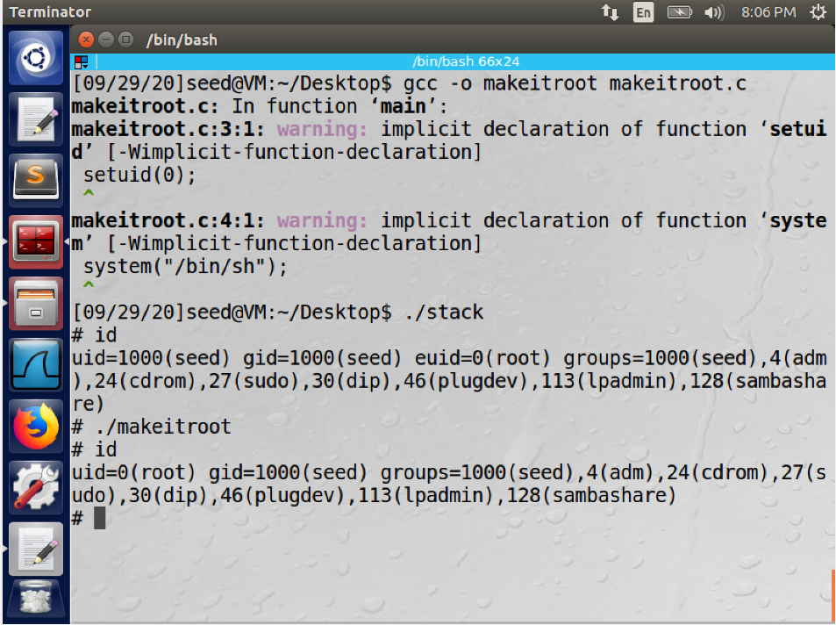

A similar operation has been performed in C programming and the result is as shown below. We run makeitroot here as well to change the uid to 0.

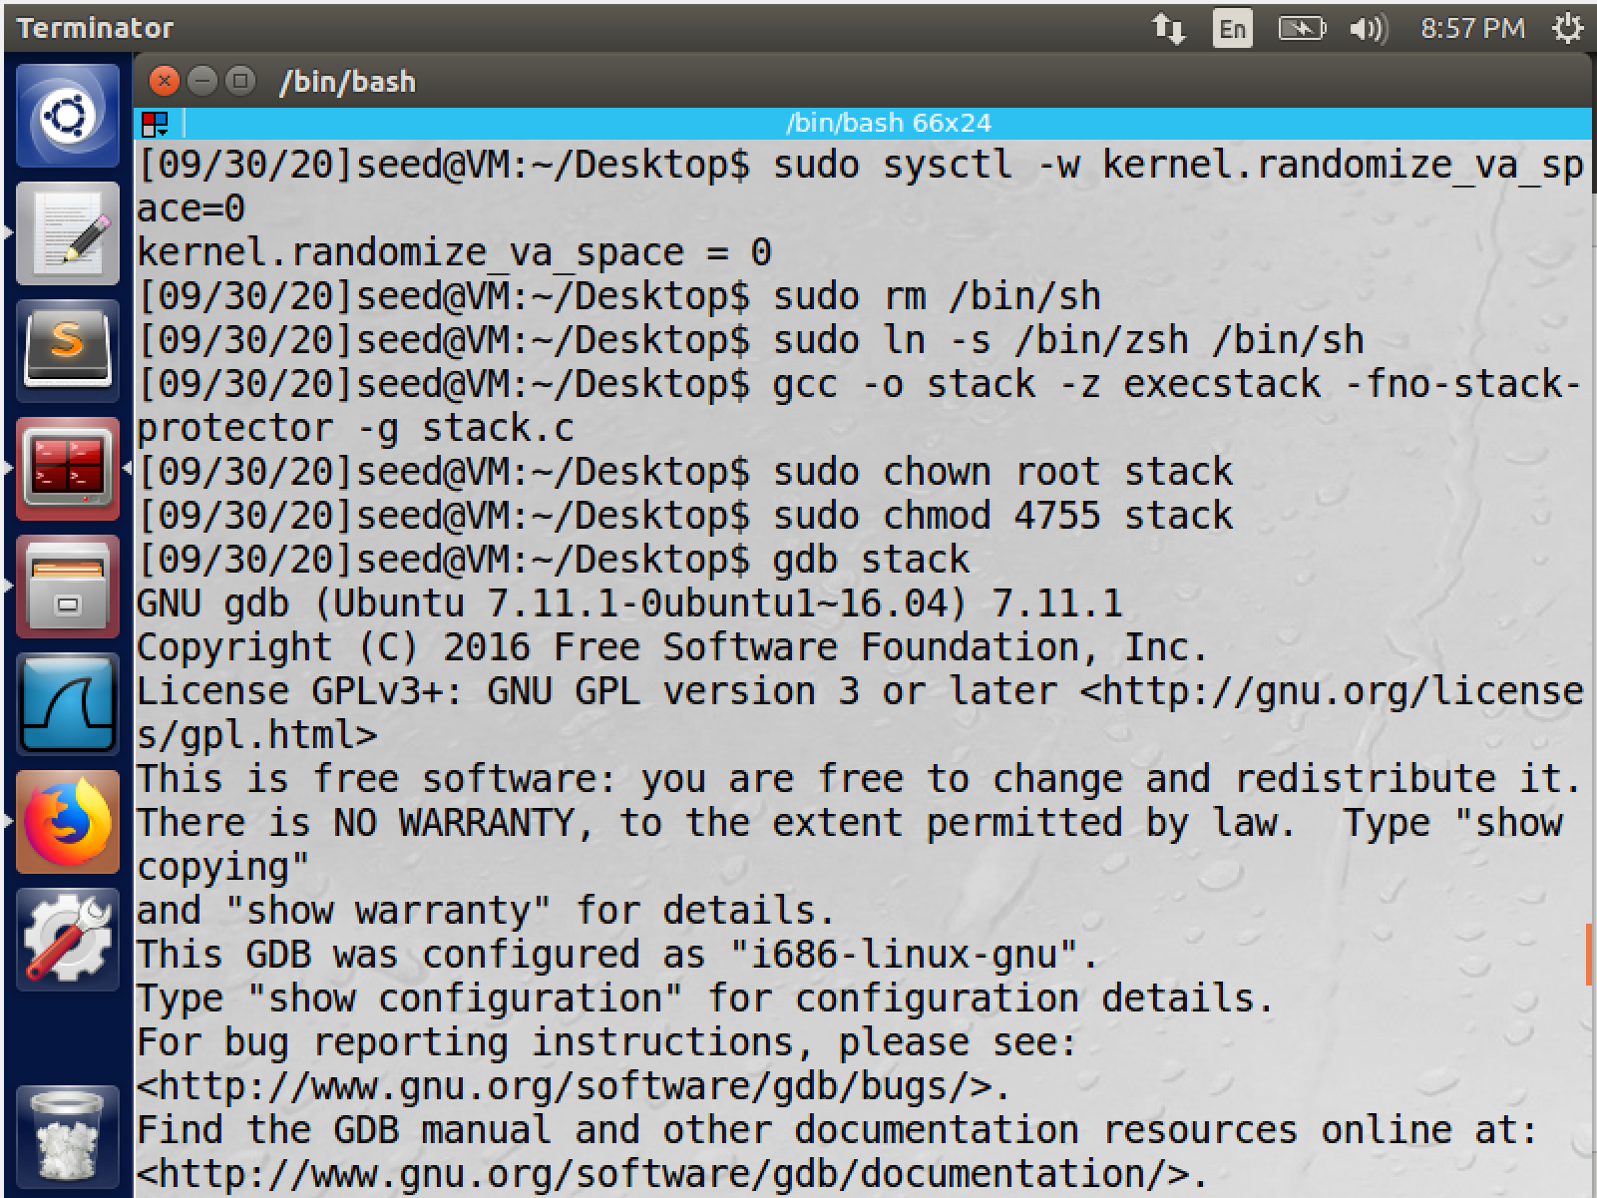

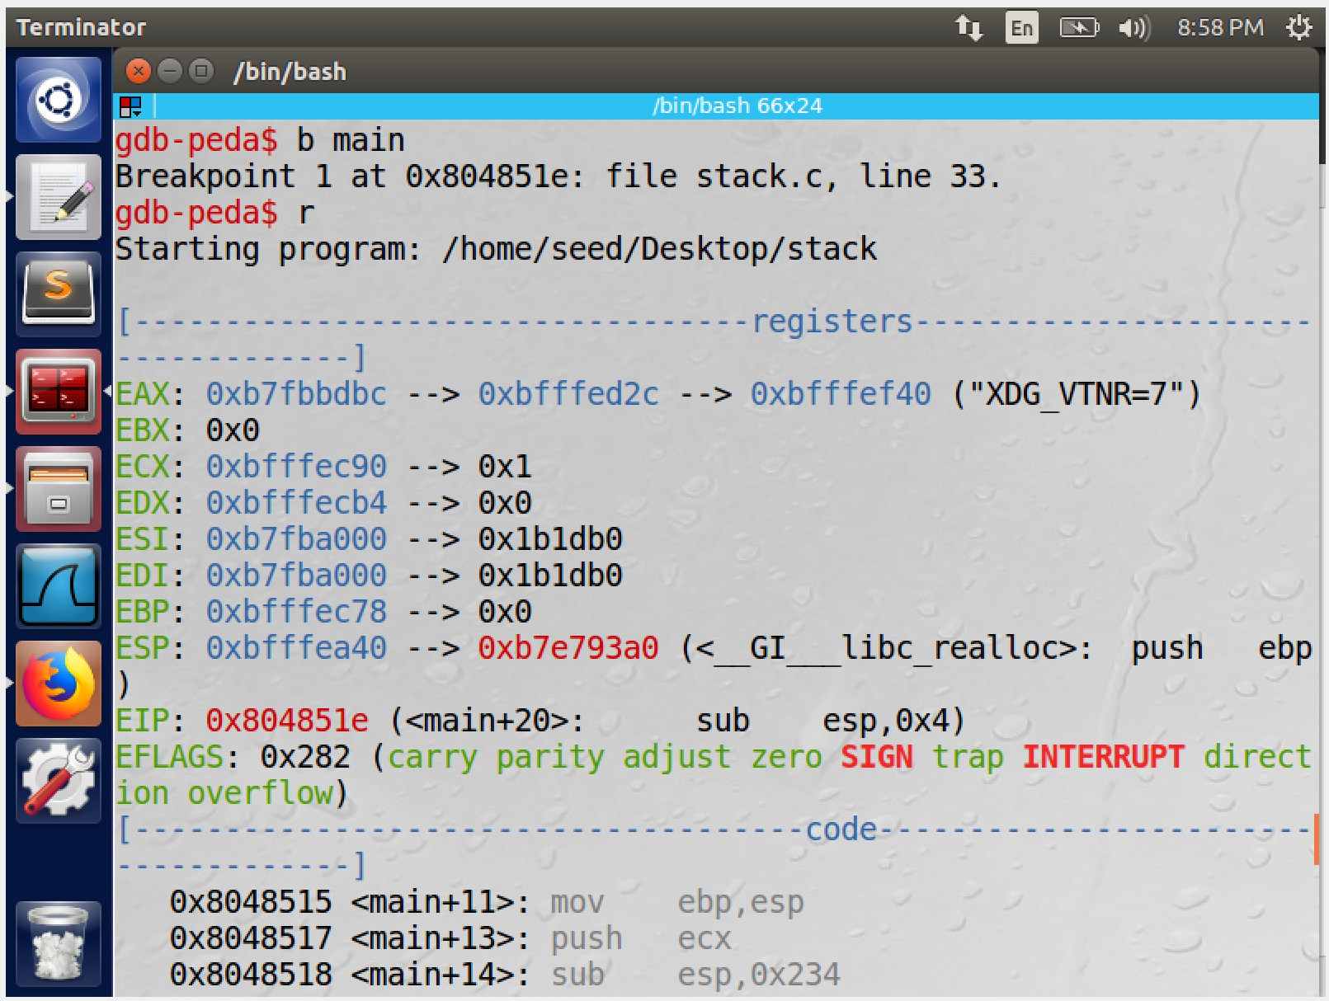

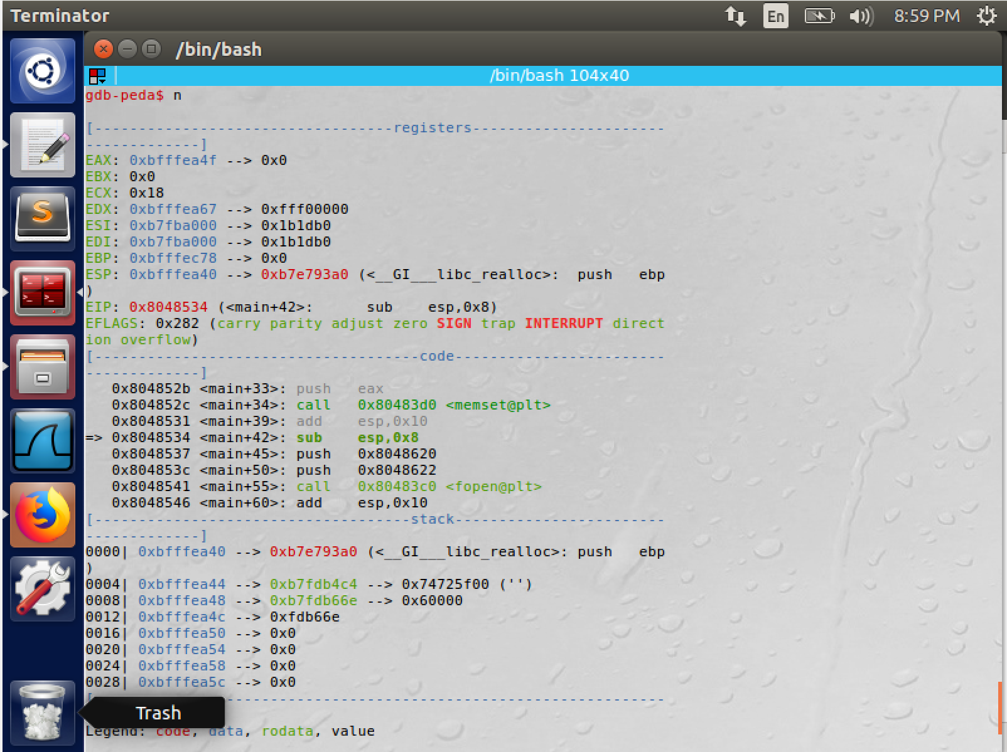

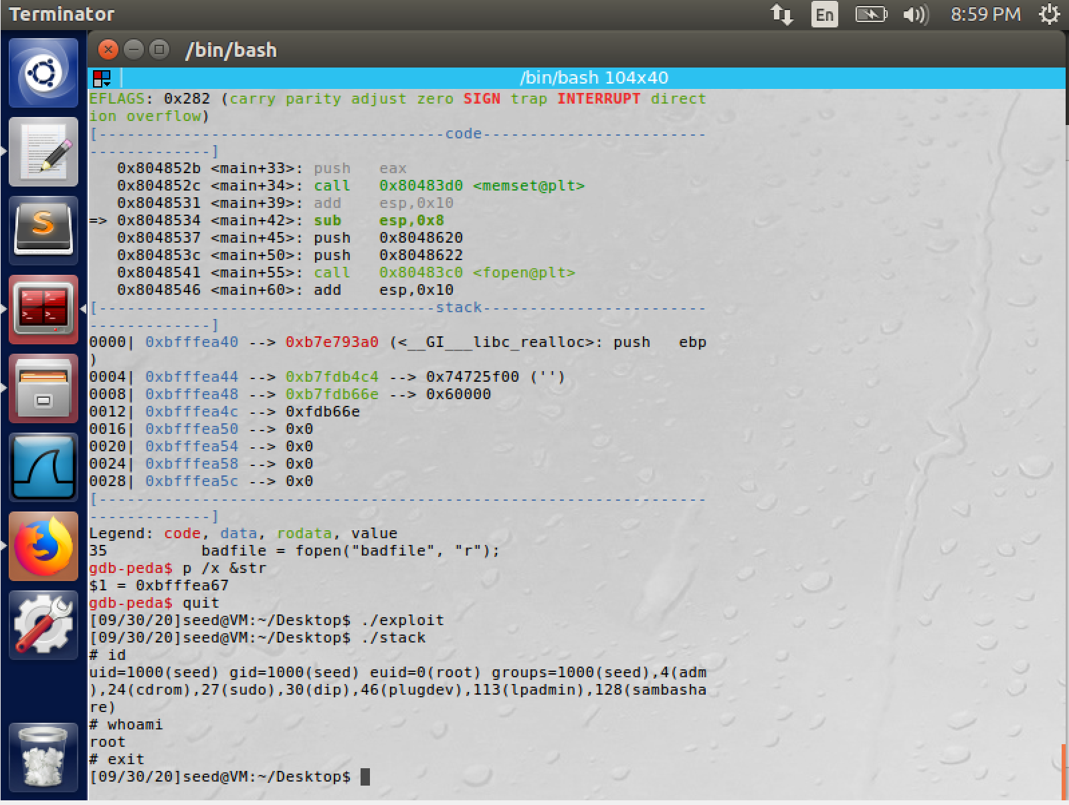

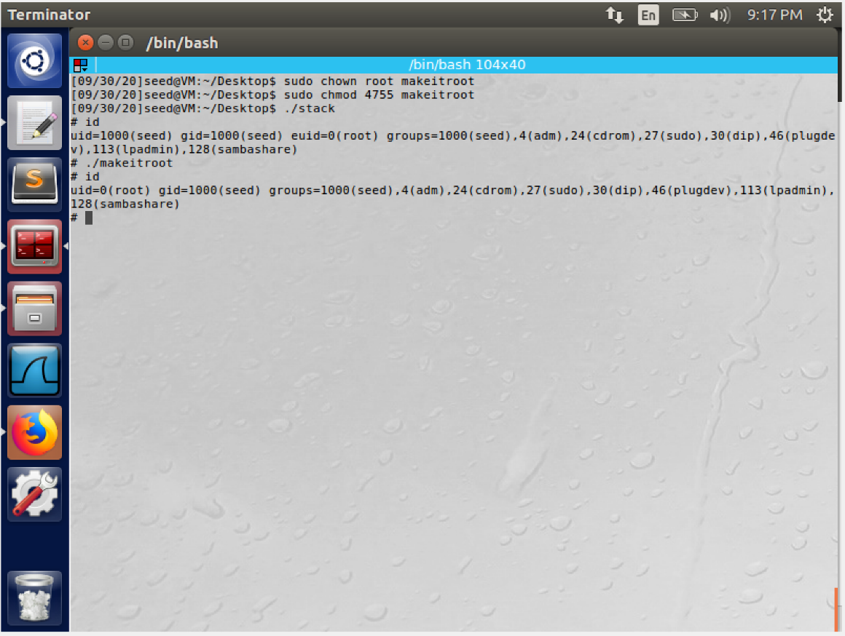

**Task 3: Defeating dash’s Countermeasure**

* we change the /bin/sh symbolic link to point it to /bin/dash.
* The dash_shell.c is compiled and made into a SETUID program.

Executing the code, we can infer that we obtain access to the shell of our account and the user id of the program is that of the seed.

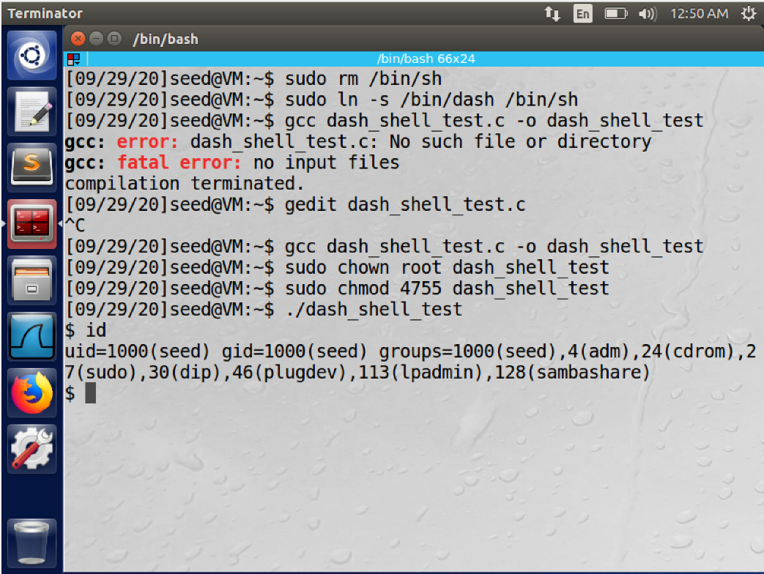

After removing the comment of in the given code, executing the program, we obtain access to the shell of the root and the user id of the program is that of the root.

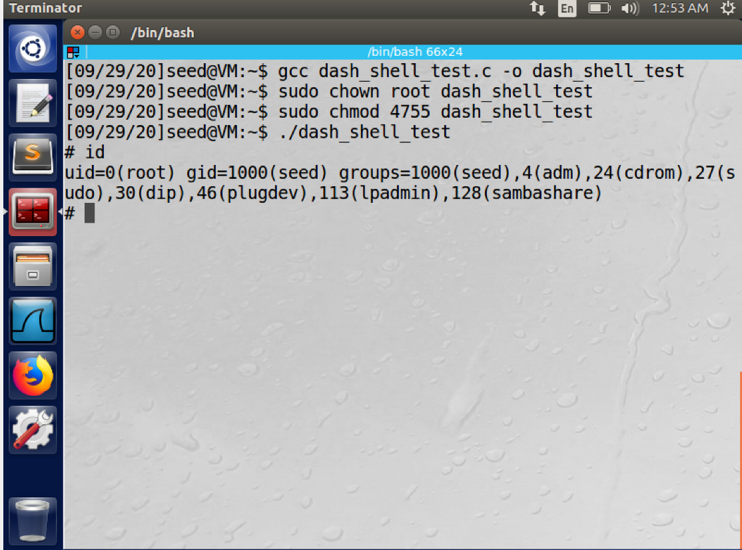

we observe that both the cases we get access to the shell, but in the first case it is that of the user and not that of the root this is due to the effective user id and the user id not being the same , the program drops the privileges of the SET-UID program. Hence, it is executed as a program with normal privileges and not as one with root privileges.

But by having the setuid command in the program, the user, and the effective user id is set to root and 0 respectively, therefore dash does not drop any privileges here, so we get a root shell.

Hence, we can conclude that the command, can defeat the dash’s countermeasure by setting the uid to that of the root for SET-UID root programs, providing with root’s terminal access.

We try to perform the buffer overflow attack, but now the /bin/dash countermeasure for SET-UID programs is present due to the symbolic link between /bin/sh and /bin/dash. We add the assembly code in the exploit.py as suggested. executing the modified exploit.py, we generate the badfile with new code to be executed in the Stack, the stack SETUID program is then run. We can see that we are able to access the root’s terminal and the UID is that of the root. Thus, we can overcome the countermeasure by using setuid() system call.

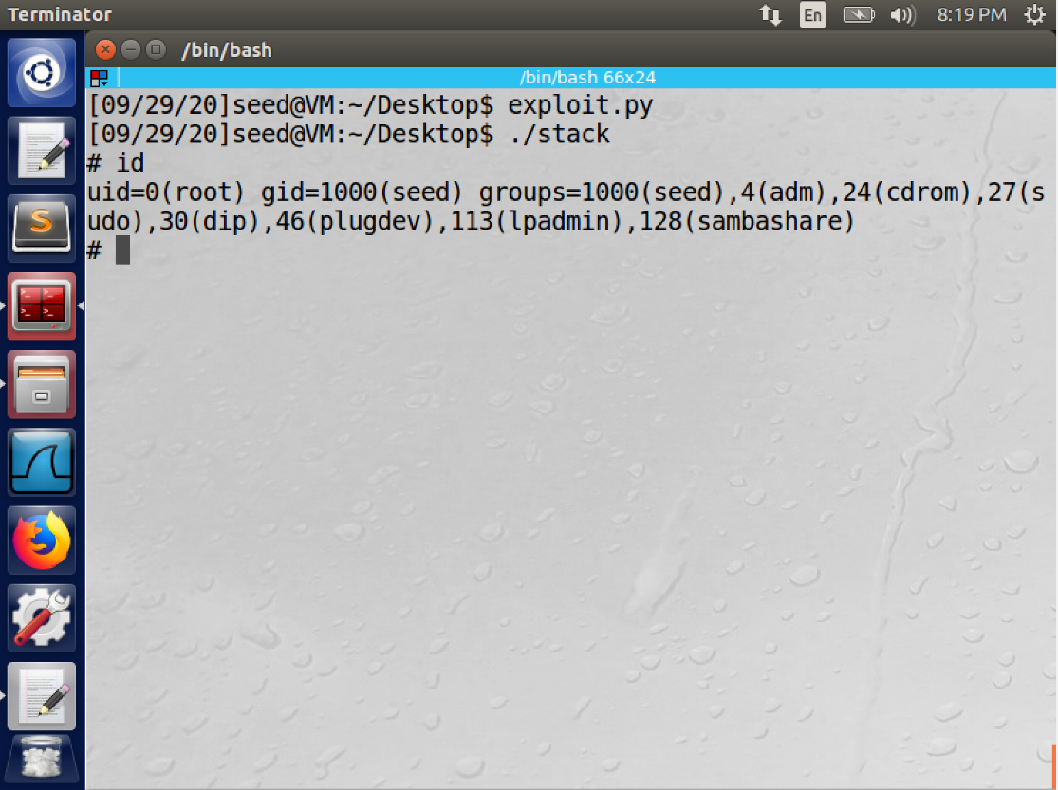

**Task 4: Defeating Address Randomization**

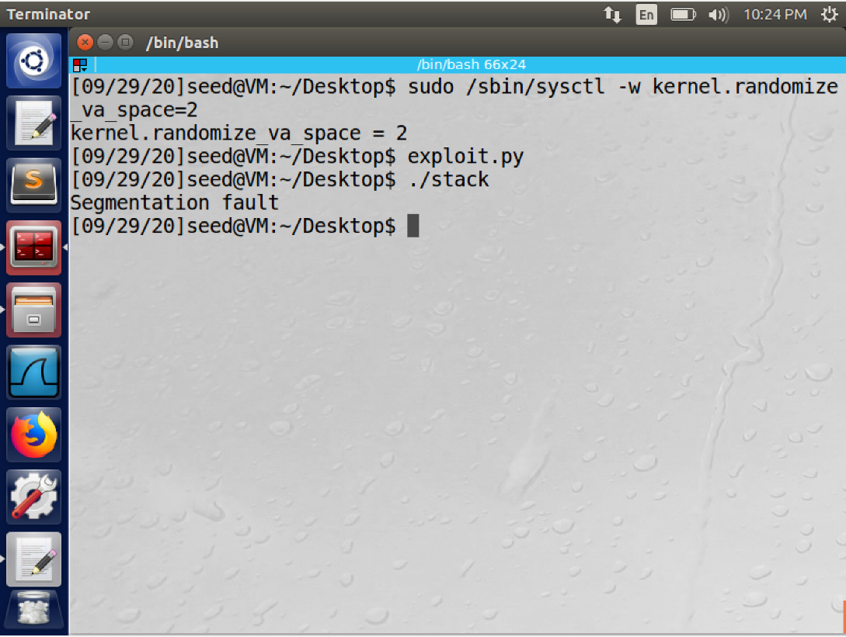

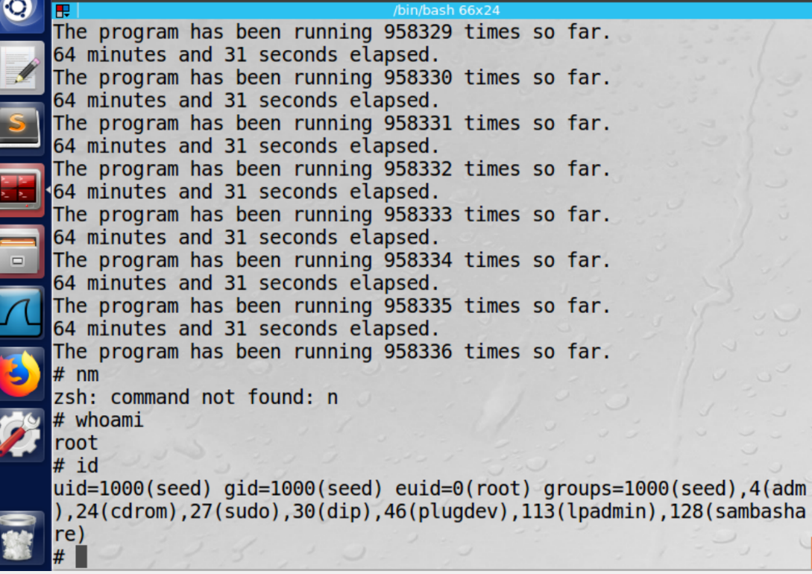

we enable address randomization by setting the value of 2. Then on running the same attack as in above tasks, we get an output of segmentation fault. Thus this demonstrates that our attack was not successfully performed

we make the provided shell script into a SET UID program and run it which runs the vulnerable program in a loop. This is a brute-force attack approach to hit the same address as the one we store in the badfile. The output is as shown it is the time taken and the number of attempts to perform the attack with Brute-Force technique. It leads to a successful buffer overflow attack

Previously we had disabled the Address Space Layout Randomization countermeasure, for each program the stack frame always started from the same point in the memory. This made it possible for us to find the offset, (the difference between the return address and the start of the buffer) and to place the malicious codes and respective return addresses.

But, with the Address Space Layout Randomization countermeasure enabled, the starting point of the stack frame is always randomized and different thus making it difficult to locate the starting or the offset points to perform the buffer overflow.

The only solution to this given scenario is to try as many number of times as possible to hit the address that is specified in the vulnerable code. On running the brute force program, the program will run until the desired address is hit. Therefore we get into the root which is shown by the # symbol

**Task 5: Turn on the StackGuard Protection**

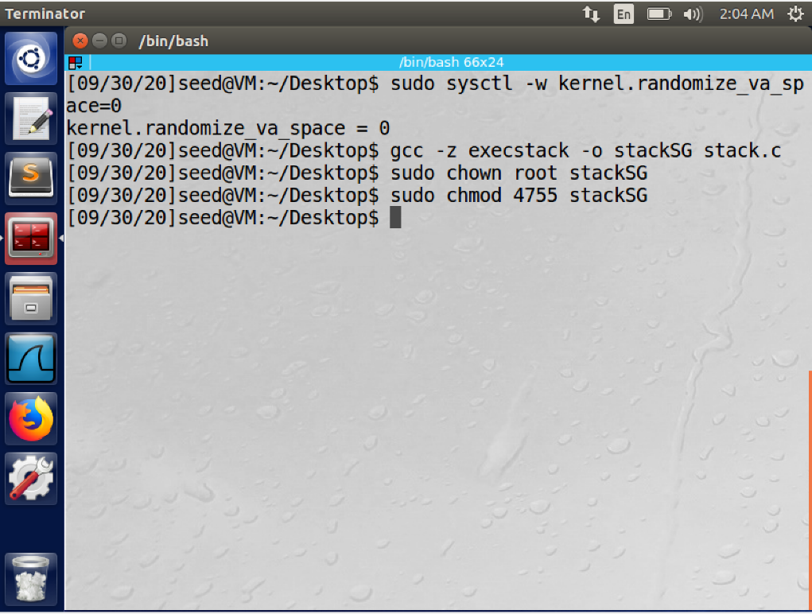

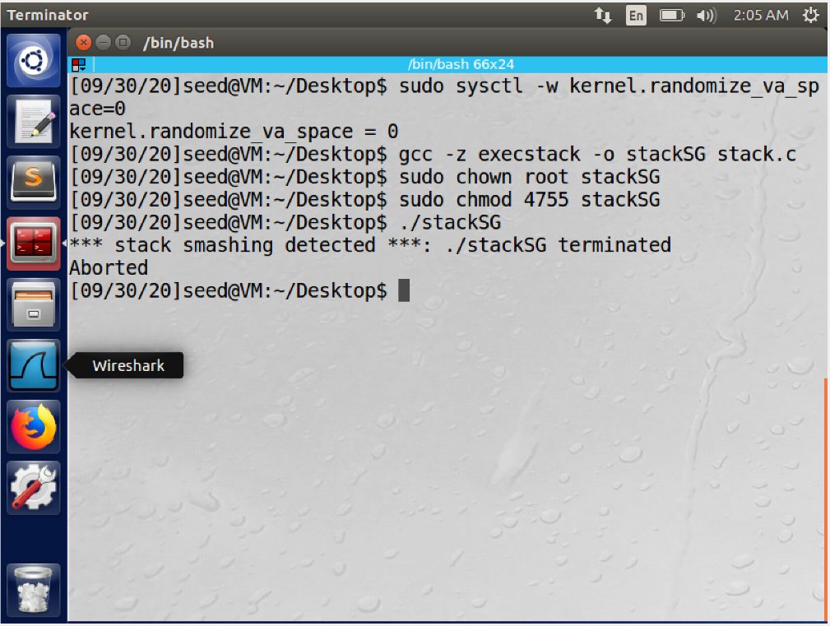

We disable the address randomization countermeasure. Then we compile the program ‘stack.c’ with StackGuard Protection and executable stack . it is then made into a SET-UID program.

Next, we run this vulnerable stack program, and see that the buffer overflow attempt is not successful because of the error shown(Stack smashing detected), and the process is aborted. Thus, this demonstrates that with StackGuard Protection mechanism, Buffer Overflow attack can be detected and prevented.

**Task 6: Turn on the Non-executable Stack Protection**

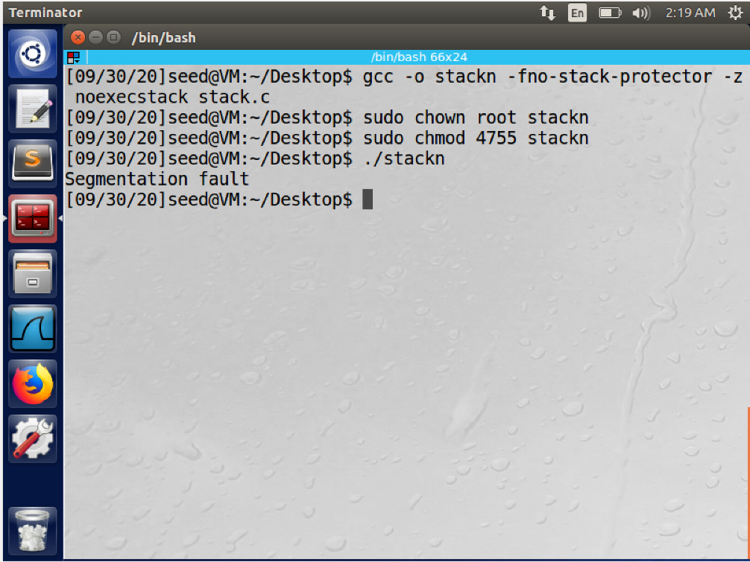

We compile the program with StackGuard Protection disabled , as a nonexecutable and a SET-UID root program . Upon executing the program, we get the output “Segmentation Fault” which shows that the buffer overflow attack was not successful.

We get this error because the stack is no longer executable. The main aim of Buffer Overflow attack is to facilitate root access. But this program is generally stored in stack and we try to enter a return address that points to that malicious program. The stack memory layout shows that it stores certain type of variables that do not need executables. So all these values will not have any requirement for execution and the stack need not be executable. Thus, by making it non-executable, normal programs will still proceed the same without any changes, but the malicious programs will be treated as read only data rather than code. Thus, the attacks fail.

**References:**

<https://github.com/firmianay/Life-long-Learner/tree/master/SEED-labs>